**PYTHON TO MYSQL & PROJECT**

Also user can install from vscode (save **as connection.py**)

After executing the code you can check the database connection has been established.

Create another file called as **database.py**

Then save another file as **database1.py**

Once table created using python you can see the table in the sql as well.

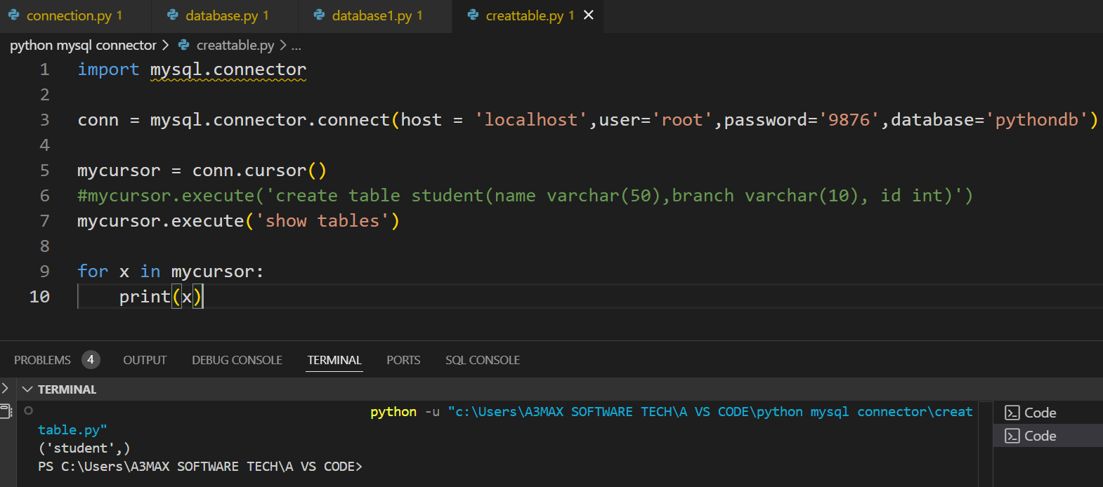

Insert **multiple record** to the table –

**WORK WITH PYTHON PROJECT WITH MYSQL 🡪**

Save the file with **EMPREGISTRATION.PY** file

Once execute above code frontend file will be displayed –

After write the code create new database in mysql tkinter

Once you write the backend code then below query will execute

Then you can check to the database – all records will be added.